**A PRELIMINARY REPORT ON**

“TVS BASE HOSPITAL”

SUBMITTED TO THE EDUBRIDGE INDIA PRIVATE LIMITED

**SUBMITTED BY**

**Miss.THAMIZHAZHAKI.S Batch No: EON-5755**

## Under The Guidance of

Amruta Deore



# DEPARTMENT OF S PRAYAS CERTIFIED JAVA FULL STACK DEVELOPER 02

**THANE**

**EDUBRIDGE INDIA PRIVATE LIMITED 2021-2022.**

# ACKNOWLEDGMENT

It gives all of us great pleasure in presenting the preliminary project report on **“TVS BASE HOSPITAL”**. With due respect and gratitude we would like to take this opportunity to thank internal guide of our project **Mrs.Amruta Deore** for giving us all the help and guidance we needed. We are really grateful for her kind support. She has always encouraged us and given us the motivation to move ahead. She has put in a lot of time and effort in this project along with us and given us a lot of confidence. Also we wish to thank all the other people who have helped us in the successful completion of this project.

**Miss.Thamizhazhaki Selvaganapathy**

# ABSTRACT

Hospital Management System which help normal people to know about the hospital and its location .In addition it helps to maintain make appointment for doctor checkup .Making appointment of multiple people for a big hospital is difficult by using a manual system and may be very time consuming. All these problems are solved using this project. Hospital Management System is a software which is helpful for normal people to make an easy appointment with a doctor who is export in their respective field.Our Hospital Management System deals with the various activities related to the hospital and also to know more detail about hospital and staffs.

**Chapter 1**

# INTRODUCTION

* 1. **INTRODUCTION**

Hospital Management System is making appointment of people for a big hospital is difficult by using a manual system and may be very time consuming. Hospital Management System allows user to keep up to date profile . It’ll also facilitate keeping all the records of users, such as their id, name, mailing, address, phone number. So all the information about an user will be available and provide personalized experience.

# SCOPE

Without a Hospital Management System, appointment and tips of doctors and speciality of hospital is difficult for normal people. Hospital Management System have a lots of information about hospital .In addition it have request information and we can give feedback to the hospital .we can also easy to find location of hospital by the help of website link.

# SYSTEM REQUIREMENTS

## Software Requirements

1. Operating System - Windows 10.
2. Platform – Eclipse IDE.
3. Language - HTML, CSS, Javascript.
4. Files – stylesheet ,html.

# UML DIAGRAMS

## Use case Diagram

The following UML use case diagram shows the working of a Hospital Management System.Moreover, it has eight use cases that show the particular functionality of the media provider. The six use cases are; appointment form, doctor info, choose department of doctors, Make request information ,process of appointment ,manage feedback form.The user, on the other hand, easy find the location of hospital .The interactions of the user and management system are what sum up the hospital management use case diagram example.

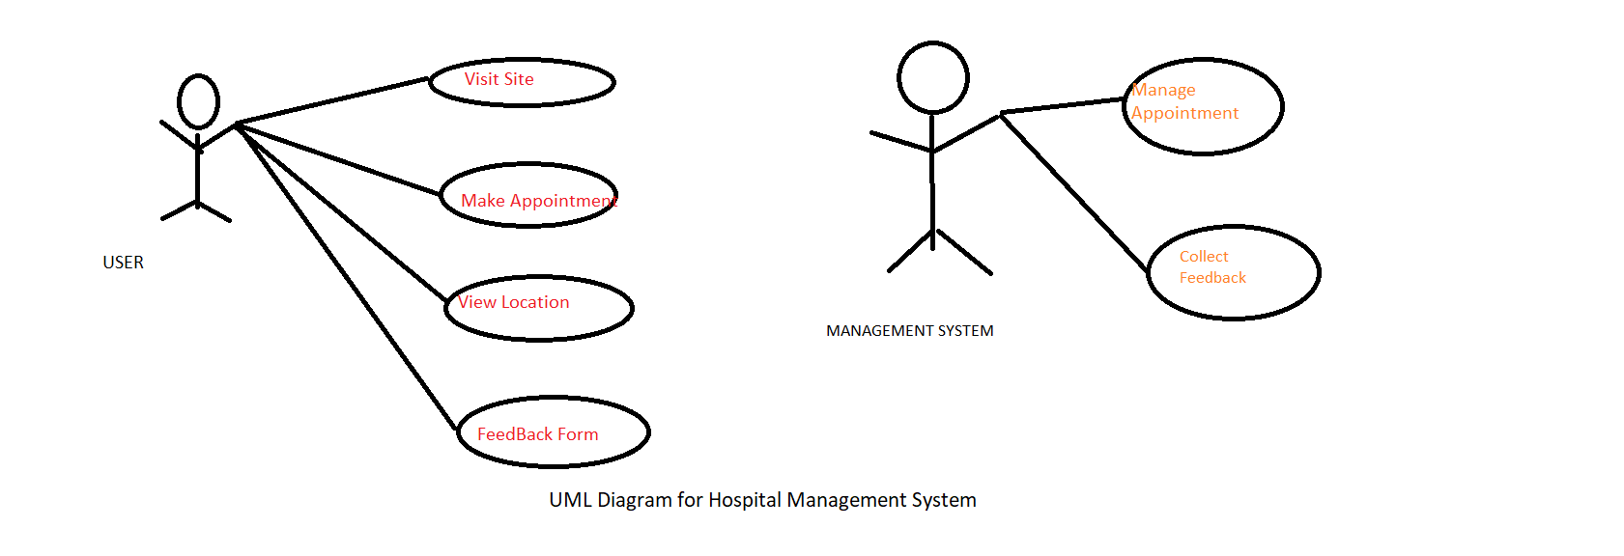

# MODULE

## WELCOME

Welcome module will help to know about the hospital .Any one can see website of our hospital management.

HTML file

<!DOCTYPE html>

<html>

<head>

<meta charset=*"ISO-8859-1"*>

<title>Welcome to TVS HOSPITAL</title>

<link type=*"text/css"* rel=*"stylesheet"* href=*"mystyle.css"*>

</head>

<body>

<section class=*"intro"*>

<div class=*"top"*>

<div id=*"menu"* align=*"center"*>

<ul><b>

<li><a href=*"home.html"*>HOME</a></li>

<li><a href=*"#"*>ABOUT US</a>

<ul class=*"drop"*>

<li><a href=*"aboutus.html"*>Introduction</a></li>

<li><a href=*"rules.html"*>Rules&Regulations</a></li>

<li><a href=*"staff.html"*>Staff Info</a></li>

</ul></li>

<li><a href=*"#"*>DEPARTMENTS</a>

<ul class=*"drop"*>

<li><a href=*"dept-skin.html"*>Skin</a></li>

<li><a href=*"dept-dental.html"*>Dentalcare</a></li>

<li><a href=*"dept-ortho.html"*>Orthopadics</a></li>

<li><a href=*"dept-cardio.html"*>Cardiology</a></li>

<li><a href=*"dept-radio.html"*>Radiology</a></li>

<li><a href=*"dept-surgery.html"*>Surgery</a></li>

<li><a href=*"dept-physio.html"*>Physiotherapists</a></li>

</ul>

</li>

<li><a href=*"#"*>EVENTS</a>

<ul class=*"drop"*>

<li><a href=*"conf&work.html"*><font size=*"3.5px"*>Conference & Workshop</font></a></li>

<li><a href=*"currentevent.html"*><font size=*"3.5px"*>Current Events</font></a></li>

<li><a href=*"trainning.html"*><font size=*"3.5px"*>Trainning</font></a></li>

</ul>

</li>

<li><a href=*"appoint.html"*>APPOINTMENT</a></li>

<li><a href=*"#"*>CONTACT US</a>

<ul class=*"drop"*>

<li><a href=*"cont-reqinfo.html"*>Request Info</a></li>

<li><a href=*"cont-feedback.html"*>Feedback</a></li>

</ul>

</li>

</b></ul>

</div>

</div>

<div class=*"det"*>

<br>TVS HOSPITAL<br>

E-mail:tvs@gmail.com<br>

Call-04364 277135 <br><br>

</div>

<div class=*"inner"*>

<div class=*"innerbg"*>

<h1><b>WELCOME TO TVS BASE HOSPITAL</b></h1>

<a class=*"start"* href=*"#second"*><b>GET STARTED</b></a>

</div>

</div>

</section>

<hr color=*"darkblue"* size=*"7px"* id=*"second"*>

<div class=*"para1"*><div class=*"middle1"*>Get Cared For By The Best &nbsp;</div><br><br>

<p class=*"middlepara1"*> &nbsp;&nbsp;&nbsp;<br>TVS HOSPITALITY is home to some of the most eminent doctors in the world, most of whom are pioneers inthe respected areas and reowned for devoloping innovative and revoultionary procedures.Many of our doctors are also 'Padma Sri','Padma Bhusan'<br></p>

<p><br><br><br><br><br><br></p>

</div>

<hr color=*"darkblue"* size=*"7px"* id=*"second"*>

<div class=*"para2"*><div class=*"middle2"*><br><br><br><br>Healthcare Meets Lifestyle &nbsp;</div>

<p class=*"middlepara2"*> &nbsp;&nbsp;&nbsp;<br>Our annual Preventive Health Checks are customized to take into consideration your lifestyle and risk factors.Our health checks include comprehensive diagnostics,consultations with accomplished doctors and technology-aided follow ups with the aim to ensure that you stay in the pink of health at all times.<br></p>

</div>

<hr color=*"darkblue"* size=*"7px"* id=*"second"* class=*"lastpara"*>

<div class=*"para3"*><div class=*"middle3"*><br><br><br><br><font color=*"brown"*>Where Healthcare Meets Hospitality&nbsp;</font></div>

<p class=*"middlepara3"*> &nbsp;&nbsp;&nbsp;<br>At TVS HOSPITAL,you will instantly discover that you are so much more than just a patient.Right from the way we nhave designed our patient rooms to the way we serve you.we have left no stone unturned,ensure that both ,your medical and personal needs are placed above everything else.</p><br>

<p></p>

</div>

<br><br>

<div class=*"copyright"*><br>copyright@2021 TVS HOSPITALITY.Kollidam,Tamilnadu.

Contents Published on this Website are Manged and Maintained by Thamizhazhaki.<br>

All Rights are Reserved.<br><br>

</div>

<div class=*"maintained"*>

<marquee> OWNED by Thamizh</marquee></div><br>

</body>

</html>

CSS file for welcome page

*{

padding: 0;

margin: 0;

}

\***html**,**body**

{

margin: 0px;

}

*.intro*

{

height: 100%;

width: 100%;

background: *url("www.jpeg") no-repeat* 50%50% *fixed*;

background-size:*cover*;

}

*.inner*

{

display: *table-cell*;

vertical-align: *middle*;

width: 120%;

max-width: *none*;

}

*.innerbg*

{

max-width:800px;

text-align:*center*;

margin:180px;

}

*.innerbg* **h1**

{

font-family:*'Raleway','Gill Sans', 'Gill Sans MT', Calibri, 'Trebuchet MS',* sans-serif;

color:darkorange;

text-shadow:15px15px800pxdarkgoldenrod;

font-size: 400%;

margin-left:200px;

margin-right:-300px;

margin-top:180px;

margin-bottom: 70px;

}

*.start*

{

border-radius:9px;

font-family:*'Oswald',*sans-serif;

color:yellow;

font-size: 135%;

padding:10px20px;

border: *solid#02386E* 3px;

text-decoration:*none*;

margin-left:400px;

margin-right:-350px;

margin-top:180px;

}

*.start*:hover

{

color: red;

border: *solid* red3px;

box-shadow: 2px2px300px *#e00a0d*;

}

*.para1*

{

text-align:*center*;

font-size: 60px;

line-height: 100%;

font-family: sans-serif;

color:yellow;

padding: 10px;

background: *url("docto.png")no-repeat*;

background-size: *cover*;

}

*.para2*

{

text-align:*center*;

font-size: 60px;

line-height: 100%;

font-family: sans-serif;

color:white;

padding: 20px;

background: *url("intro1.jpeg")no-repeat*;

background-size: *cover*;

}

*.para3*

{

text-align:*center*;

font-size: 60px;

line-height: 100%;

font-family: sans-serif;

color:black;

padding: 20px;

background: *url("pat.jpg")no-repeat* 50%50%;

background-size: *cover*;

}

*.middle1*

{

font-family:*"ariel"*;

font-weight:*bolder*;

font-size: 70px;

color:chartreuse;

margin-top:70px;

}

*.middlepara1*

{

color: black;

font-size:40px;

padding:0px90px0px90px;

line-height:70px;

}

*.middle2*

{

font-family: Georgia*, 'Times New Roman',* Times*,* serif;

font-weight:*bolder*;

font-size: 50px;

color:black;

margin-top:70px;

text-align:*left*;

}

*.middlepara2*

{

color:whitesmoke;

font-size:30px;

padding:0px300px0px0px;

line-height:70px;

text-align: *justify*;

margin-top:-10px;

}

*.middle3*

{

font-family:*"Ariel"*;

font-weight:*bolder*;

font-size: 50px;

color:whitesmoke;

margin-top:70px;

text-align:*left*;

}

*.middlepara3*

{

color:black;

font-size:30px;

padding:0px300px0px0px;

line-height:70px;

text-align: *justify*;

margin-top:-10px;

}

*.copyright*

{

text-align:*center*;

padding:0px80px0px80px;

background: *#05548e*;

color: white;

font-family: *"Arial"*;

line-height: 20px;

}

*.det*

{

text-align:*right*;

padding:0px80px0px80px;

background: *#05548e*;

color: white;

font-family: *"Lucida Grande"*;

line-height: 15px;

}

*.maintained*

{

text-align:*right*;

padding:0px80px0px80px;

background: *#05548e*;

color: aqua;

font-family:*'Lucida Sans Unicode', 'Lucida Grande', 'Lucida Sans', 'Arial', 'sans-serif'*;

line-height: 20px;

}

*.top*

{

padding:0px;

float: *left*;

position: *fixed*;

margin-left: 45px;

}

*#menu* **ul**

{

list-style: *none*;

box-shadow:10px25px75px30pxwhite;

opacity:0.98;

}

*#menu* **ul** **li**

{

background-color:055*bfc*;

border:1px *solid #055bfc*;

width: 190px;

height:65px;

line-height:65px;

text-align: *center*;

float: *left*;

position: *relative*;

border-radius:8px;

margin:1.5px;

}

*#menu*

{

margin: *auto*;

}

*#menu* **ul** **li**:nth-child(1)

{

width:200px;

}

*#menu* **ul** **li**:nth-child(2)

{

width:200px;

}

*#menu* **ul** **li**:nth-child(3)

{

width:200px;

}

*#menu* **ul** **li**:nth-child(4)

{

width:200px;

}

*#menu* **ul** **li**:nth-child(6)

{

width:200px;

}

*#menu* **ul***.drop* **li**

{

width:200px;

background-color:yellowgreen;

border:*solid* yellowgreen;

margin:1px;

margin-left:*auto*;

}

*#menu* **ul** **li** **a**

{

text-decoration: *none*;

color: red;

display: *block*;

font-family:*"Maiandra GD"*;

font-size:125%;

}

*#menu* **ul** **li** **a**:hover

{

background-color: cyan;

border:1px *solid#229954*;

border-radius:6px;

font-size:120%;

font-family:*"Maiandra GD"*;

box-shadow:0px0px20px0pxwhite;

}

*#menu* **ul** **ul**

{

position: *absolute*;

display: *none*;

}

*#menu* **ul** **li**:hover>**ul**

{

display: *block*;

}

*#menu* **ul** **li**:hover>**ul**

{

animation:*load ls forwards*;

animation-duration:600ms;

animation-name: *menu*;

}

@keyframes menu

{

0%

{

opacity:0;

transform: rotatey*(*-90deg*)*translateY*(*30px*)*;

}

100%

{

opacity:1;

transform: rotatey*(*-90deg*)*translateY*(*30px*)*;

}

}

Screenshots of Welcome page

Before hover

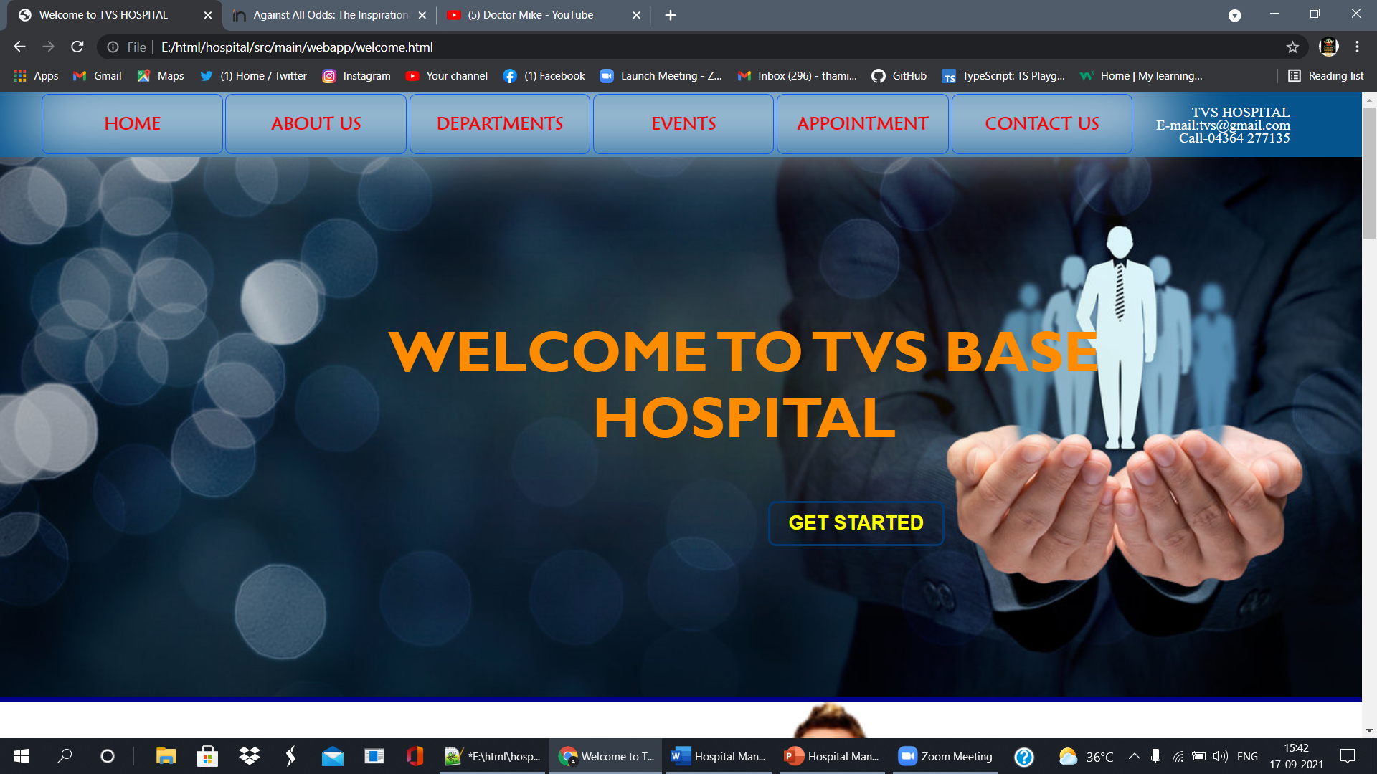

After hover

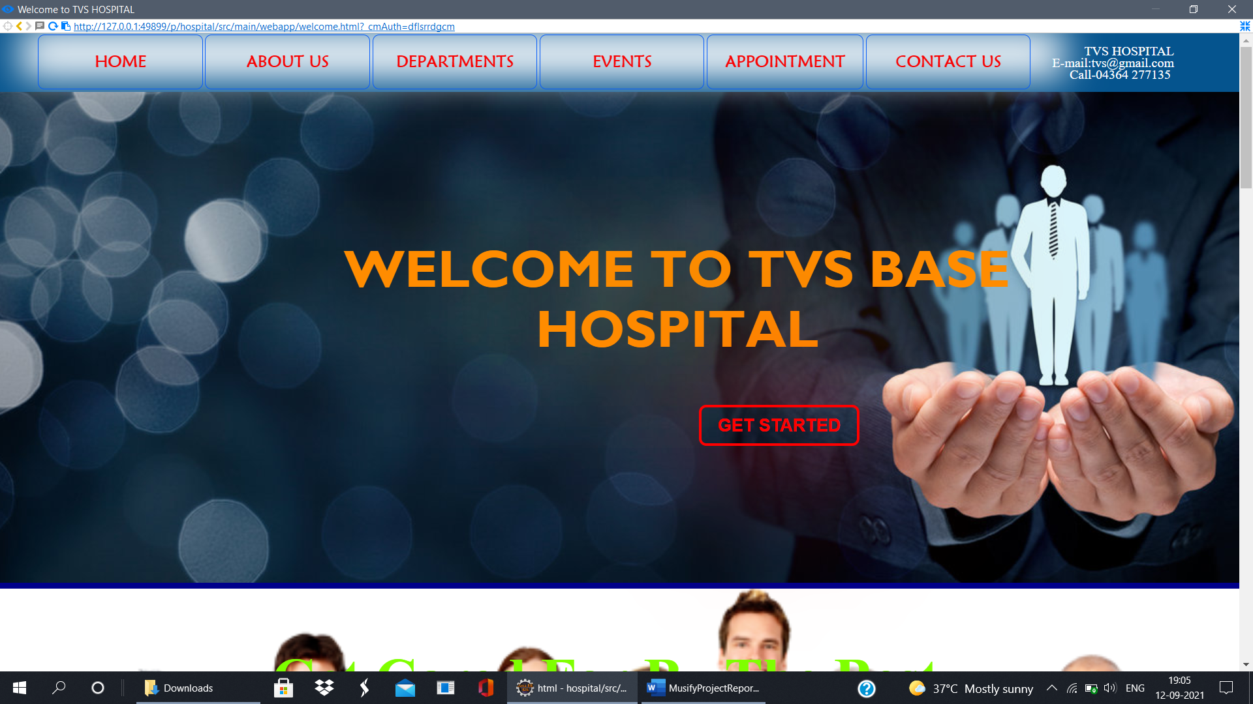

Dropdown the departments

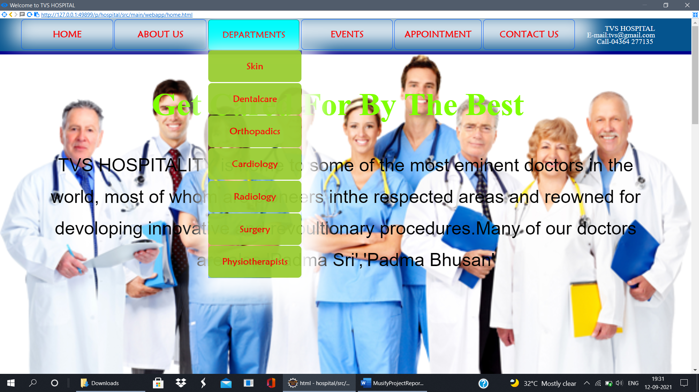

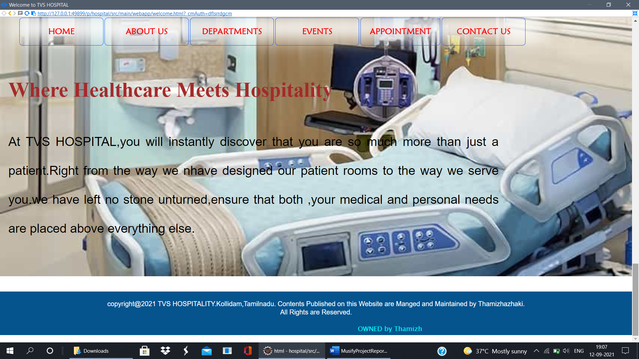

## DEPARTMENTS

This module will help to know about the hospital departments easily, and information about hospital.

HTML for Departments

<html>

<head>

<title>dept-radio</title>

<link href="pagestyle.css" rel="stylesheet" type="text/css">

</head>

<body>

<div class="dett">

<center><a href="home.html" class="home">HOME</a></center>

TVS HOSPITAL<br>

E-mail:tvs@gmail.com<br>

Call-04364 277135

</div>

<h1><font size="6">RADIOLOGY DEPARTMENT</font></h1><br><br>

<img src="radio.jpeg" height="350px" width="400px" allign="right">

<p class="additional">

Radiology is also known as diagnostic imaging. ... Radiology is useful in several operations such as CT scan, MRI, X-ray, ultrasound, etc required during diagnosis. Radiology is the principle management process of all the disease. It also contains a variety of tools and techniques for detection, analyzing, and curing.<br><br>

Radiologists are medical doctors that specialize in diagnosing and treating injuries and diseases using medical imaging (radiology) procedures (exams/tests) such as X-rays, computed tomography (CT), magnetic resonance imaging (MRI), nuclear medicine, positron emission tomography (PET) and ultrasound.<br><br>

Radiologists are medical doctors (MDs) or doctors of osteopathic medicine (DOs) who have completed a 4-year residency in radiology. A radiologist may act as a consultant to another doctor who is caring for the patient, or act as the patient's primary doctor in treating a disease..<br>

About 51% of radiologists said they are happy outside of work, placing the specialty around the middle of the pack. Rheumatology and general surgery said they were most happy, both at 60%, while critical care and neurology tied as least happy at 44%.Radiology may be divided into two different areas, diagnostic radiology and interventional radiology..<br><br>

There is also a facility in the dept and used as and when required.<br><br>

ICMR and CSIR funded research projects in the field of heart care are also being carried out.<br><br>

This hospital also has modern Physiotherapy Unit which works is close co-ordination with the Radiodiology Department for comprehensive care of patients.

</p>

<a href="home.html">

<center><button type="button">back</button></center>

</a>

<br>

<div class="copyright"><br>copyright@2021 TVS HOSPITALITY.Kollidam,Tamilnadu.

Contents Published on this Website are Manged and Maintained by Thamizhazhaki.<br>

All Rights are Reserved.<br><br>

</div>

<div class="maintained">

<marquee> OWNED by Thamizh</marquee></div><br>

</body>

</html>

CSS for pages

h1

{

color: darkblue;

text-align: center;

background-color: aliceblue;

font-size: 40px;

}

body

{

background: url("abt.jpeg")no-repeat fixed;

background-size: cover;

}

.home

{

color: blue;

font-size: 70px;

text-decoration:none;

margin-right: 100px;

line-height: 25px;

font-size: 30px;

}

.home:hover

{

border:solid palevioletred 6px;

}

.dett

{

text-align:right;

padding:0px 80px 0px 80px;

background: azure;

color: blueviolet;

font-family: "Lucida Grande";

line-height: 15px;

}

.maintained

{

text-align:right;

padding:0px 80px 0px 80px;

background: #05548e;

color: aqua;

font-family:'Lucida Sans Unicode', 'Lucida Grande', 'Lucida Sans', 'Arial', 'sans-serif';

line-height: 20px;

}

.copyright

{

text-align:center;

padding:0px 80px 0px 80px;

background: azure;

color:blue;

font-family: "Arial";

line-height: 20px;

}

p{

margin: 30px;

line-height: 30px;

font-size: 25px;

color: aliceblue;

font-family: Georgia, 'Times New Roman', Times, serif;

}

p.additional

{

margin: 30px;

margin-right: 100px;

line-height: 25px;

font-size: 20px;

color: aliceblue;

font-family: 'Courier New', Courier, monospace;

text-align: justify;

}

p.additional1

{

margin: 30px;

margin-right: 350px;

line-height: 25px;

font-size: 20px;

color: aliceblue;

font-family: 'Lucida Sans', 'Lucida Sans Regular', 'Lucida Grande', 'Lucida Sans Unicode', Geneva, Verdana, sans-serif;

text-align: justify;

}

table,th,td

{

margin: auto;

border: 1px solid #ffffff;

border-collapse: collapse;

font-family: 'arial';

}

th

{

font-size: 20px;

color: white;

}

td

{

color: white;

}

.rules

{

margin-left: 330px;

margin-top: -15px;

}

h2

{

color: antiquewhite;

margin-left: 20px;

text-decoration: underline;

}

Screenshots of Departments

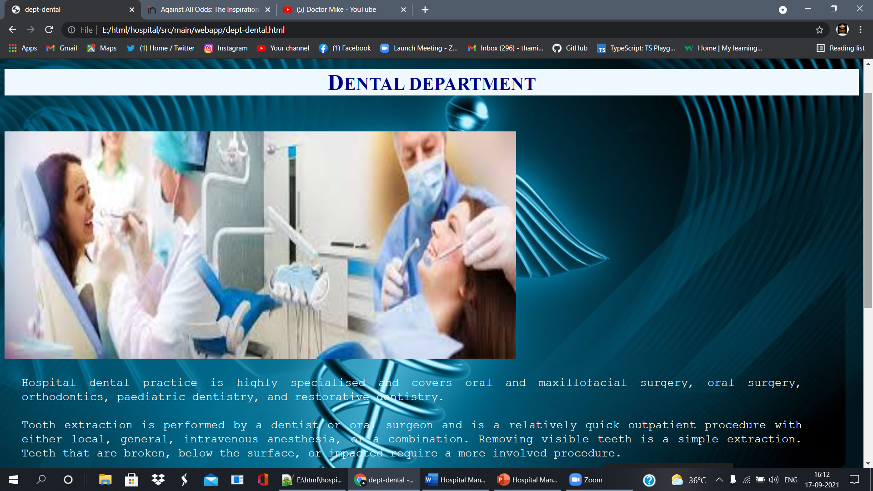

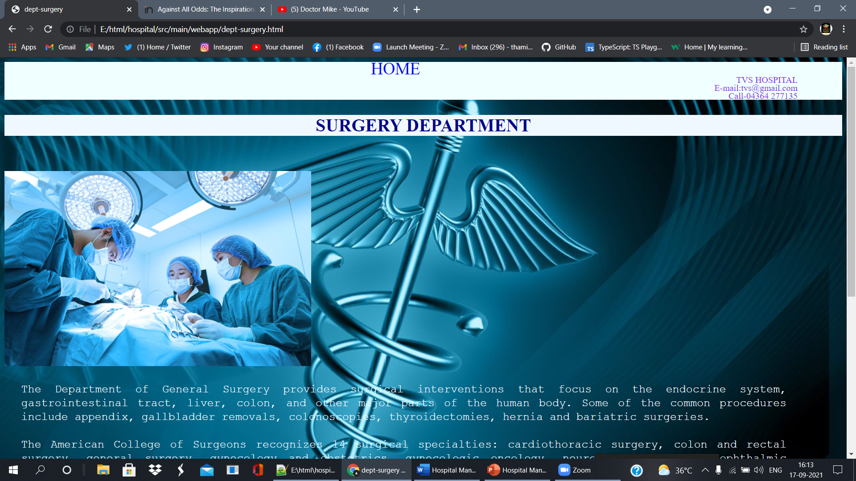

## STAFF INFORMATION

This module will help to view doctors detail and doctors website.

HTML& CSS file

<!DOCTYPE html>

<html>

<head>

<title>staff</title>

<style>

.top

{

padding:0px;

float: left;

position: fixed;

margin-left: 45px;

}

#menu ul

{

list-style: none;

box-shadow:10px 25px 75px 30px white;

opacity:0.98;

}

#menu ul li

{

background-color:brown;

border:1px solid burlywood;

width: 190px;

height:65px;

line-height:65px;

text-align: center;

float: left;

position: relative;

border-radius:8px;

margin:1.5px;

}

#menu

{

margin: auto;

}

#menu ul li:nth-child(1)

{

width:200px;

}

#menu ul li:nth-child(2)

{

width:200px;

}

#menu ul li:nth-child(3)

{

width:200px;

}

#menu ul li:nth-child(4)

{

width:200px;

}

#menu ul li:nth-child(6)

{

width:200px;

}

#menu ul.drop li

{

width:200px;

background-color:yellowgreen;

border:solid yellowgreen;

margin:1px;

margin-left:auto;

}

#menu ul li a

{

text-decoration: none;

color: white;

display: block;

font-family:"Maiandra GD";

font-size:125%;

}

#menu ul li a:hover

{

background-color: cyan;

border:1px solid#229954;

border-radius:6px;

font-size:120%;

font-family:"Maiandra GD";

box-shadow:0px 0px 20px 0px white;

}

#menu ul ul

{

position: absolute;

display: none;

}

#menu ul li:hover>ul

{

display: block;

}

#menu ul li:hover>ul

{

animation:load ls forwards;

animation-duration:600ms;

animation-name: menu;

}

@keyframes menu

{

0%

{

opacity:0;

transform: rotatey(-90deg)translateY(30px);

}

100%

{

opacity:1;

transform: rotatey(-90deg)translateY(30px);

}

}

.button

{

border-radius: 2%;

height: 3%;

width: 5%;

}

div.gallery {

border: 1px solid #ccc;

}

div.gallery:hover {

border: 1px solid #777;

}

div.gallery img {

width: 100%;

height: auto;

}

div.desc {

padding: 15px;

text-align: center;

}

* {

box-sizing: border-box;

}

.responsive {

padding: 0 6px;

float: left;

width: 24.99999%;

}

@media only screen and (max-width: 700px) {

.responsive {

width: 49.99999%;

margin: 6px 0;

}

}

@media only screen and (max-width: 500px) {

.responsive {

width: 100%;

}

}

.clearfix:after {

content: "";

display: table;

clear: both;

}

.copyright

{

text-align:center;

padding:0px 80px 0px 80px;

background: #05548e;

color: white;

font-family: "Arial";

line-height: 20px;

}

.det

{

text-align:right;

padding:0px 10px 0px 80px;

background: #05548e;

color: white;

font-family: "Lucida Grande";

line-height: 15px;

}

.maintained

{

text-align:right;

padding:0px 80px 0px 80px;

background: #05548e;

color: aqua;

font-family:'Lucida Sans Unicode', 'Lucida Grande', 'Lucida Sans', 'Arial', 'sans-serif';

line-height: 20px;

}

</style>

</head>

<body>

<section class="intro">

<div class="top">

<div id="menu" align="center">

<ul><b>

<li><a href="home.html">HOME</a></li>

<li><a href="#">ABOUT US</a>

<ul class="drop">

<li><a href="aboutus.html">Introduction</a></li>

<li><a href="rules.html">Rules&Regulations</a></li>

<li><a href="staff.html">Staff Info</a></li>

</ul>

</li>

<li><a href="#">DEPARTMENTS</a>

<ul class="drop">

<li><a href="dept-skin.html">Skin</a></li>

<li><a href="dept-dental.html">Dentalcare</a></li>

<li><a href="dept-ortho.html">Orthopadics</a></li>

<li><a href="dept-cardio.html">Cardiology</a></li>

<li><a href="dept-radio.html">Radiology</a></li>

<li><a href="dept-surgery.html">Surgery</a></li>

<li><a href="dept-physio.html">Physiotherapists</a></li>

</ul>

</li>

<li><a href="#">EVENTS</a>

<ul class="drop">

<li><a href="conf&work.html"><font size="3.5px">Conference & Workshop</font></a></li>

<li><a href="currentevent.html"><font size="3.5px">Current Events</font></a></li>

<li><a href="trainning.html"><font size="3.5px">Trainning</font></a></li></ul></li>

<li><a href="appoint.html">APPOINTMENT</a></li>

<li><a href="#">CONTACT US</a>

<ul class="drop">

<li><a href="cont-reqinfo.html">Request Info</a></li>

<li><a href="cont-feedback.html">Feedback</a></li> </ul></li>

</b></ul>

</div></div>

<div class="det">

<br>TVS HOSPITAL<br>

E-mail:tvs@gmail.com<br>

Call-04364 277135 <br><br>

</div>

</section>

<center><h1><font color="blue">STAFFS</font></h1></center>

<h4><font color="blue">Click on Doctor image to watch about their tips of healthy life. </font></h4>

<div class="responsive">

<div class="gallery">

<a target="_blank" href="https://www.youtube.com/c/DoctorMike/videos">

<img src="john.jpeg" alt="DR.John" width="600" height="400">

</a>

<div class="desc">Dr.Jhon Mike... Chief Doctor</div>

</div>

</div>

<div class="responsive">

<div class="gallery">

<a target="_blank" href="https://www.kauveryhospital.com/doctors/chennai/anaesthesiology/dr-velmurugan-deisingh">

<img src="vel.jpg" alt="vel" width="600" height="400">

</a>

<div class="desc">Dr.Velmurugan...Best anaesthesiology</div>

</div>

</div>

<div class="responsive">

<div class="gallery">

<a target="_blank" href="https://www.india.com/viral/karnatakas-first-trans-woman-doctor-trinetra-haldar-gummaraju-shares-inspirational-journey-against-all-odds-4231464/">

<img src="transwomen.webp" alt="Northern Lights" width="600" height="400">

</a>

<div class="desc">Dr.Hasini....1st Transwomen doctor</div>

</div>

</div>

<div class="responsive">

<div class="gallery">

<a target="_blank" href="https://www.beebehealthcare.org/doctors/nisarg-desai-md">

<img src="neraj.jpg" width="600" height="400">

</a>

<div class="desc">R.Neeraj Best Healthcare</div>

</div>

</div>

<div class="clearfix"></div>

<div class="copyright">copyright@2021 TVS HOSPITALITY.Kollidam,Tamilnadu.

Contents Published on this Website are Manged and Maintained by Thamizhazhaki.<br>

All Rights are Reserved.<br>

</div>

<div class="maintained">

<marquee> OWNED by Thamizh</marquee></div><br>

</body>

</html>

Screenshots of Staff Information

Before clicking Doctor image

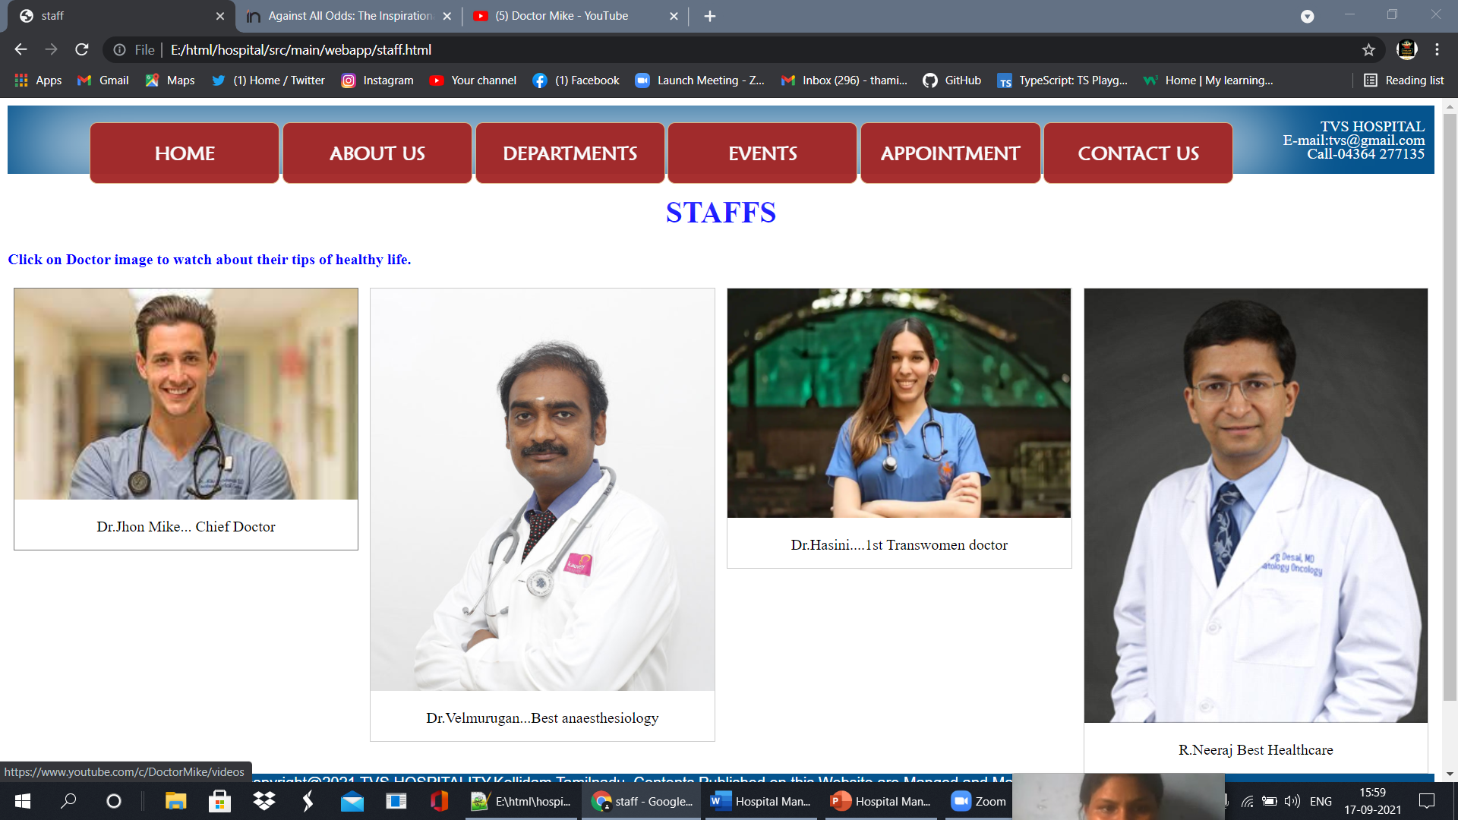

After clicking Doctor image

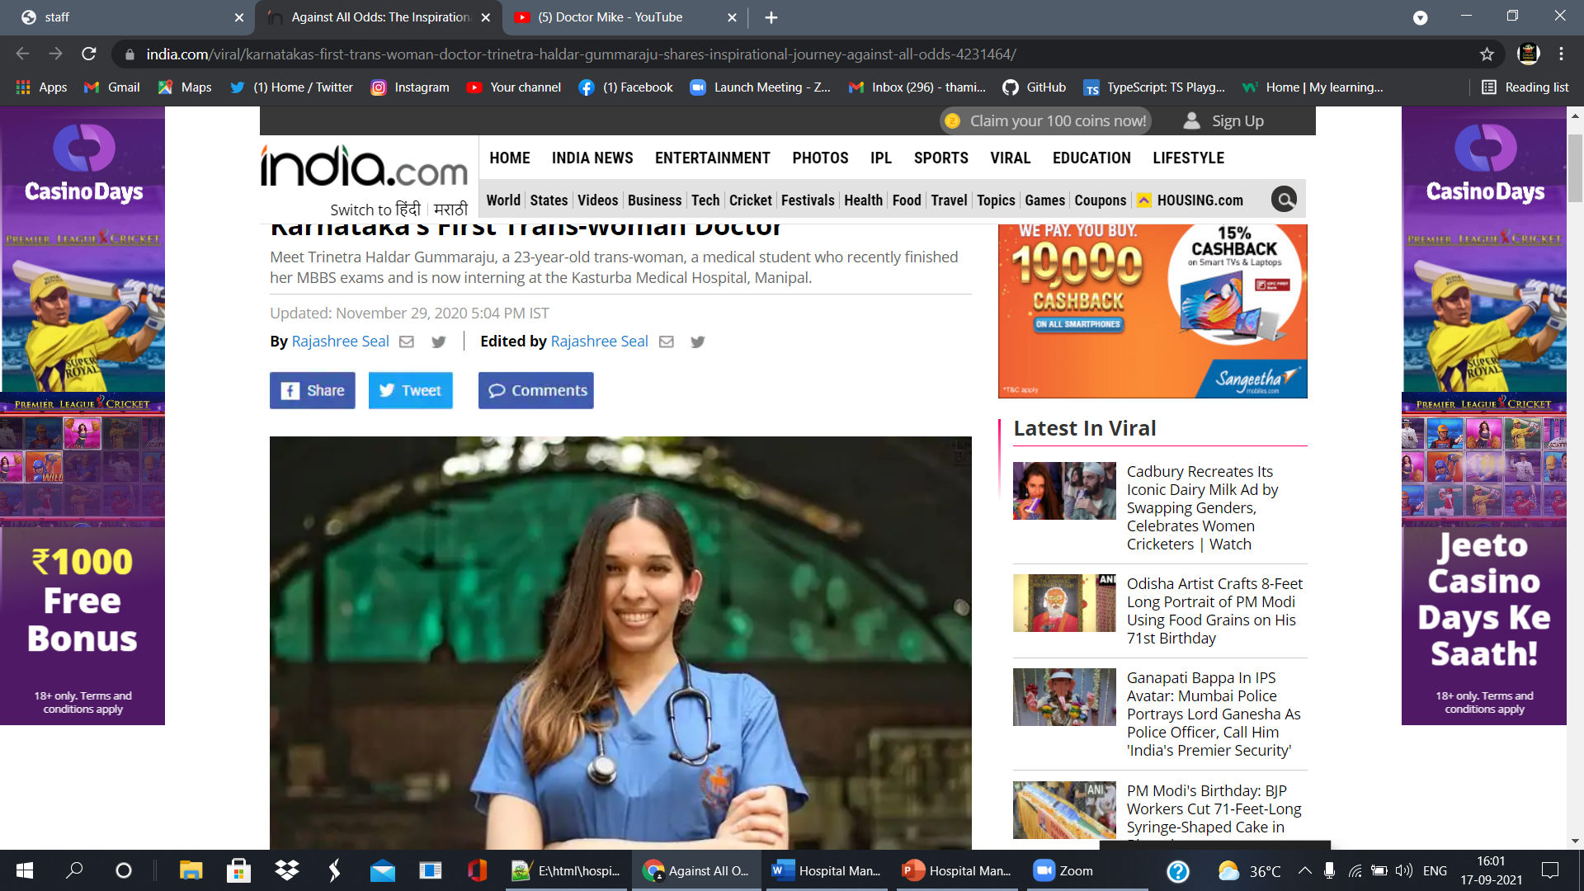

## EVENTS

HTML Events

<html>

<head>

<title>currentevent</title>

<link href="pagestyle.css" rel="stylesheet" type="text/css">

</head>

<body>

<div class="dett">

<center><a href="home.html" class="home">HOME</a></center>

TVS HOSPITAL<br>

E-mail:tvs@gmail.com<br>

Call-04364 277135

</div>

<h1>C<font size="6">URRENT EVENTS</font></h1>

<br>

<table>

<tr><th width="90px">S.No</th><th><font size="+2">Events Title</font></th>

<th width="180px">Date of Uploading</th><th width="200px">

Date of closing</th></tr>

<tr align="center"><td height="150px">1</td><td align="left"> &nbsp;Event1 <font color="#ffffff"><br><b>AASNS Education Couse &workshop,2021</b></font><br><br>

The Asian Australian Society of Neurological Surgeons(AASNS)Neuro Trauma Education Course & Workshop is being held at Sirkali,Mayavaram,India on 4th&5th September 2021 at the Convention Hall of Peacock Hall.<br>

</td><td>04-09-2021</td><td>16-09-2021</td></tr>

<tr align="center"><td height="150px">2</td><td align="left"> &nbsp;Event2 <font color="#ffffff"><br><b>7th International Patient Safety Conference</b></font><br><br>

The International Patient Safety Conference(IPSC),the annual event to learnt from patient safety experts across the world.<br>

</td><td>01-12-2021</td><td>16-12-2021</td></tr>

</table> <br>

<a href="home.html">

<center><button type="button">back</button></center>

</a> <br>

<div class="copyright"><br>copyright@2021 TVS HOSPITALITY.Kollidam,Tamilnadu.

Contents Published on this Website are Manged and Maintained by Thamizhazhaki.<br>

All Rights are Reserved.<br><br>

</div>

<div class="maintained">

<marquee> OWNED by Thamizh</marquee></div><br>

</body>

</html>

CSS for Pages

h1

{

color: darkblue;

text-align: center;

background-color: aliceblue;

font-size: 40px;

}

body

{

background: url("abt.jpeg")no-repeat fixed;

background-size: cover;

}

.home

{

color: blue;

font-size: 70px;

text-decoration:none;

margin-right: 100px;

line-height: 25px;

font-size: 30px;

}

.home:hover

{

border:solid palevioletred 6px;

}

.dett

{

text-align:right;

padding:0px 80px 0px 80px;

background: azure;

color: blueviolet;

font-family: "Lucida Grande";

line-height: 15px;

}

.maintained

{

text-align:right;

padding:0px 80px 0px 80px;

background: #05548e;

color: aqua;

font-family:'Lucida Sans Unicode', 'Lucida Grande', 'Lucida Sans', 'Arial', 'sans-serif';

line-height: 20px;

}

.copyright

{

text-align:center;

padding:0px 80px 0px 80px;

background: azure;

color:blue;

font-family: "Arial";

line-height: 20px;

}

p{

margin: 30px;

line-height: 30px;

font-size: 25px;

color: aliceblue;

font-family: Georgia, 'Times New Roman', Times, serif;

}

p.additional

{

margin: 30px;

margin-right: 100px;

line-height: 25px;

font-size: 20px;

color: aliceblue;

font-family: 'Courier New', Courier, monospace;

text-align: justify;

}

p.additional1

{

margin: 30px;

margin-right: 350px;

line-height: 25px;

font-size: 20px;

color: aliceblue;

font-family: 'Lucida Sans', 'Lucida Sans Regular', 'Lucida Grande', 'Lucida Sans Unicode', Geneva, Verdana, sans-serif;

text-align: justify;

}

table,th,td

{

margin: auto;

border: 1px solid #ffffff;

border-collapse: collapse;

font-family: 'arial';

}

th

{

font-size: 20px;

color: white;

}

td

{

color: white;

}

.rules

{

margin-left: 330px;

margin-top: -15px;

}

h2

{

color: antiquewhite;

margin-left: 20px;

text-decoration: underline;

}

Screenshots of Events

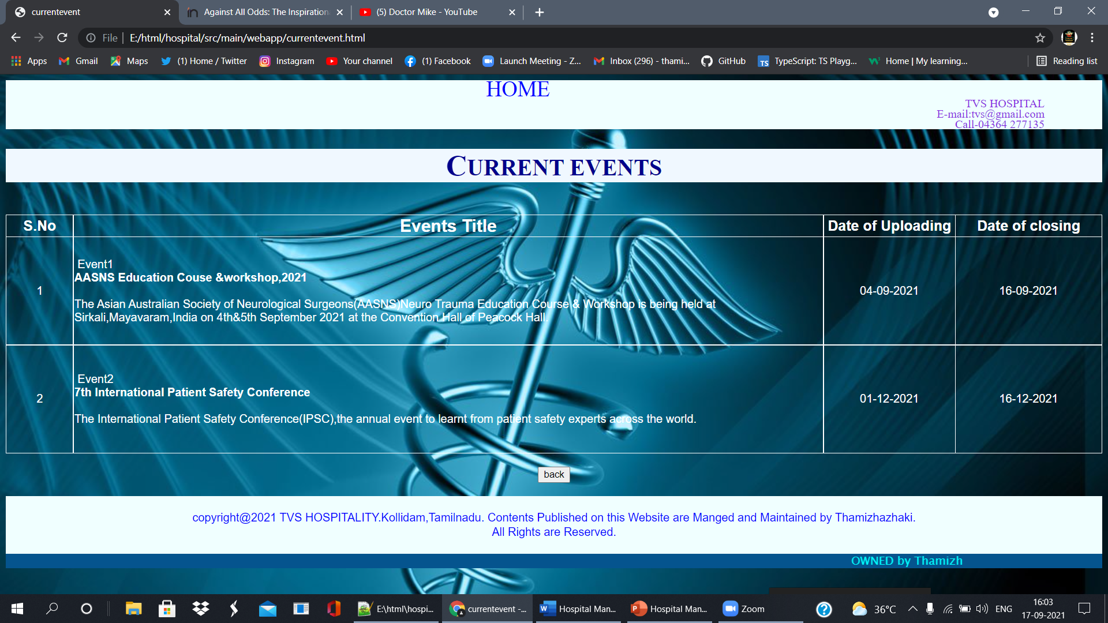

## APPOINTMENT FORM

This module will help the patient to make an easy appointment from anywhere if internet is present.

HTML file

<html>

<head>

<title>appointment</title>

<link type=*"text/css"* rel=*"stylesheet"* href=*"appointstyle.css"*>

</head>

<body>

<section class=*"intro"*>

<div class=*"top"*>

<div id=*"menu"* align=*"center"*>

<ul><b>

<li><a href=*"home.html"*>HOME</a></li>

<li><a href=*"#"*>ABOUT US</a>

<ul class=*"drop"*>

<li><a href=*"aboutus.html"*>Introduction</a></li>

<li><a href=*"rules.html"*>Rules&Regulations</a></li>

<li><a href=*"staff.html"*>Staff Info</a></li>

</ul>

</li>

<li><a href=*"#"*>DEPARTMENTS</a>

<ul class=*"drop"*>

<li><a href=*"dept-skin.html"*>Skin</a></li>

<li><a href=*"dept-dental.html"*>Dentalcare</a></li>

<li><a href=*"dept-ortho.html"*>Orthopadics</a></li>

<li><a href=*"dept-cardio.html"*>Cardiology</a></li>

<li><a href=*"dept-radio.html"*>Radiology</a></li>

<li><a href=*"dept-surgery.html"*>Surgery</a></li>

<li><a href=*"dept-physio.html"*>Physiotherapists</a></li>

</ul>

</li>

<li><a href=*"#"*>EVENTS</a>

<ul class=*"drop"*>

<li><a href=*"conf&work.html"*><font size=*"3.5px"*>Conference & Workshop</font></a></li>

<li><a href=*"currentevent.html"*><font size=*"3.5px"*>Current Events</font></a></li>

<li><a href=*"trainning.html"*><font size=*"3.5px"*>Trainning</font></a></li>

</ul>

</li>

<li><a href=*"appoint.html"*>APPOINTMENT</a></li>

<li><a href=*"#"*>CONTACT US</a>

<ul class=*"drop"*>

<li><a href=*"cont-reqinfo.html"*>Request Info</a></li>

<li><a href=*"cont-feedback.html"*>Feedback</a></li>

</ul>

</li>

</b></ul>

</div>

</div>

<div class=*"det"*>

<br>TVS HOSPITAL<br>

E-mail:tvs@gmail.com<br>

Call-04364 277135 <br><br>

</div>

</section>

<form method=*"get"* action=*"appointsubmit.html"*>

<div class=*"patient"*><div class=*"p1"*>PATIENT INFORMATION</div>

<div class=*"pp1"*>

First Name:

<input type=*"text"* placeholder=*"firstname"* required>

Last Name:

<input type=*"text"* placeholder=*"lastname"* required><br>

Gender:

<input type=*"radio"* name=*"gender"* value=*"female"*>Female

<input type=*"radio"* name=*"gender"* value=*"male"*>Male<br>

DOB:

<input type=*"date"*><br>

Age:

<input type=*"radio"* value=*"child"*>Child

<input type=*"radio"* value=*"adult"*>Adult

<input type=*"radio"* value=*" above 50"*>Above 50<br>

Mobile No:

<input type=*"text"* placeholder=*"mobile no"* required >

</div>

</div>

<div class=*"appo"*><div class=*"p2"*>APPOINTMENT INFORMATION </div><br>

<div class=*"pp2"*>

Appointment Date:

<input type=*"date"* required><br>

Doctors & Departments:

<select>

<optgroup label=*"Cardialogy "*>

<option>Dr.Jhon</option>

<option>Dr.Tharshini</option>

</optgroup>

<optgroup label=*"Radialogy "*>

<option>Dr.Hasini</option>

<option>Dr.Ambrish</option>

</optgroup>

<optgroup label=*"Dental "*>

<option>Dr.Krishna</option>

<option>Dr.Tharsha</option>

</optgroup>

<optgroup label=*"Skincare"*>

<option>Dr.Thamizh</option>

<option>Dr.Raghul</option>

</optgroup>

<optgroup label=*"Physician"*>

<option>Dr.Janani</option>

<option>Dr.SamYuktha</option>

</optgroup>

<optgroup label=*"Phycartist "*>

<option>Dr.Thillai</option>

<option>Dr.Prakash</option>

</optgroup>

<optgroup label=*"opthamology"*>

<option>Dr.Divya</option>

<option>Dr.Sai</option>

</optgroup>

<optgroup label=*"Gastralogy "*>

<option>Dr.Bavi</option>

<option>Dr.Bala</option>

</optgroup>

</select><br>

Preferred Time:

<select >

<optgroup label=*"Morning"*>

<option>8:00 - 9:00</option>

<option>9:00 - 10:00</option>

<option>11:00 - 12:00</option>

</optgroup>

<optgroup label=*"Afternoon "*>

<option>12:00 - 01:00</option>

<option>01:00 - 02:00</option>

<option>02:00 - 03:00</option>

</optgroup>

<optgroup label=*"Evening"*>

<option>05:00 - 06:00</option>

<option>06:00 - 07:00</option>

<option>07:00 - 08:00</option>

</optgroup>

</select>

</div><br>

<a href=*"appointsubmit.html"*>

<center><button class=*"button"*> Submit</button> </center> </a><br>

<center><input type=*"reset"* class=*"button"* ></center>

</div>

</form>

<div class=*"copyright"*><br>copyright@2021 TVS HOSPITALITY.Kollidam,Tamilnadu.

Contents Published on this Website are Manged and Maintained by Thamizhazhaki.<br>

All Rights are Reserved.<br><br>

</div>

<div class=*"maintained"*>

<marquee> Maintained by Thamizh</marquee></div><br>

</body>

</html>

CSS appoint file

*{

padding: 0;

margin: 0;

}

*.patient*

{

text-align:*center*;

font-size: 30px;

line-height: 180%;

font-family: sans-serif;

color:black;

padding: 20px;

background-color: royalblue;

background-size: *cover*;

}

*.appo*

{

text-align:*center*;

font-size: 30px;

line-height: 180%;

font-family: sans-serif;

color:black;

padding: 20px;

background-color: royalblue;

background-size: *cover*;

}

*.p1*

{

font-family:*"ariel"*;

font-weight:*bolder*;

font-size: 40px;

color:yellow;

margin-top:70px;

background: darkblue;

}

*.p2*

{

font-family: Georgia*, 'Times New Roman',* Times*,* serif;

font-weight:*bolder*;

font-size: 40px;

color:yellow;

margin-top:70px;

text-align:*center*;

background: darkblue;

}

*.pp1*

{

color: white;

font-size:25px;

padding:0px90px0px90px;

line-height:70px;

}

*.pp2*

{

color:white;

font-size:25px;

padding:0px90px0px90px;

line-height:70px;

}

*.copyright*

{

text-align:*center*;

padding:0px80px0px80px;

background: *#05548e*;

color: white;

font-family: *"Arial"*;

line-height: 20px;

}

*.det*

{

text-align:*right*;

padding:0px10px0px80px;

background: *#05548e*;

color: white;

font-family: *"Lucida Grande"*;

line-height: 15px;

}

*.maintained*

{

text-align:*right*;

padding:0px80px0px80px;

background: *#05548e*;

color: aqua;

font-family:*'Lucida Sans Unicode', 'Lucida Grande', 'Lucida Sans', 'Arial', 'sans-serif'*;

line-height: 20px;

}

*.top*

{

padding:0px;

float: *left*;

position: *fixed*;

margin-left: 45px;

}

*#menu* **ul**

{

list-style: *none*;

box-shadow:10px25px75px30pxwhite;

opacity:0.98;

}

*#menu* **ul** **li**

{

background-color:brown;

border:1px *solid* burlywood;

width: 190px;

height:65px;

line-height:65px;

text-align: *center*;

float: *left*;

position: *relative*;

border-radius:8px;

margin:1.5px;

}

*#menu*

{

margin: *auto*;

}

*#menu* **ul** **li**:nth-child(1)

{

width:200px;

}

*#menu* **ul** **li**:nth-child(2)

{

width:200px;

}

*#menu* **ul** **li**:nth-child(3)

{

width:200px;

}

*#menu* **ul** **li**:nth-child(4)

{

width:200px;

}

*#menu* **ul** **li**:nth-child(6)

{

width:200px;

}

*#menu* **ul***.drop* **li**

{

width:200px;

background-color:yellowgreen;

border:*solid* yellowgreen;

margin:1px;

margin-left:*auto*;

}

*#menu* **ul** **li** **a**

{

text-decoration: *none*;

color: white;

display: *block*;

font-family:*"Maiandra GD"*;

font-size:125%;

}

*#menu* **ul** **li** **a**:hover

{

background-color: cyan;

border:1px *solid#229954*;

border-radius:6px;

font-size:120%;

font-family:*"Maiandra GD"*;

box-shadow:0px0px20px0pxwhite;

}

*#menu* **ul** **ul**

{

position: *absolute*;

display: *none*;

}

*#menu* **ul** **li**:hover>**ul**

{

display: *block*;

}

*#menu* **ul** **li**:hover>**ul**

{

animation:*load ls forwards*;

animation-duration:600ms;

animation-name: *menu*;

}

@keyframes menu

{

0%

{

opacity:0;

transform: rotatey*(*-90deg*)*translateY*(*30px*)*;

}

100%

{

opacity:1;

transform: rotatey*(*-90deg*)*translateY*(*30px*)*;

}

}

*.button*

{

border-radius: 2%;

height: 3%;

width: 5%;

}

Screenshots of Appointment form

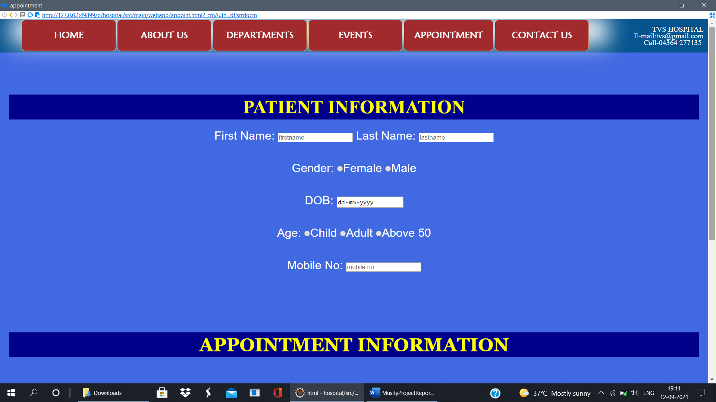

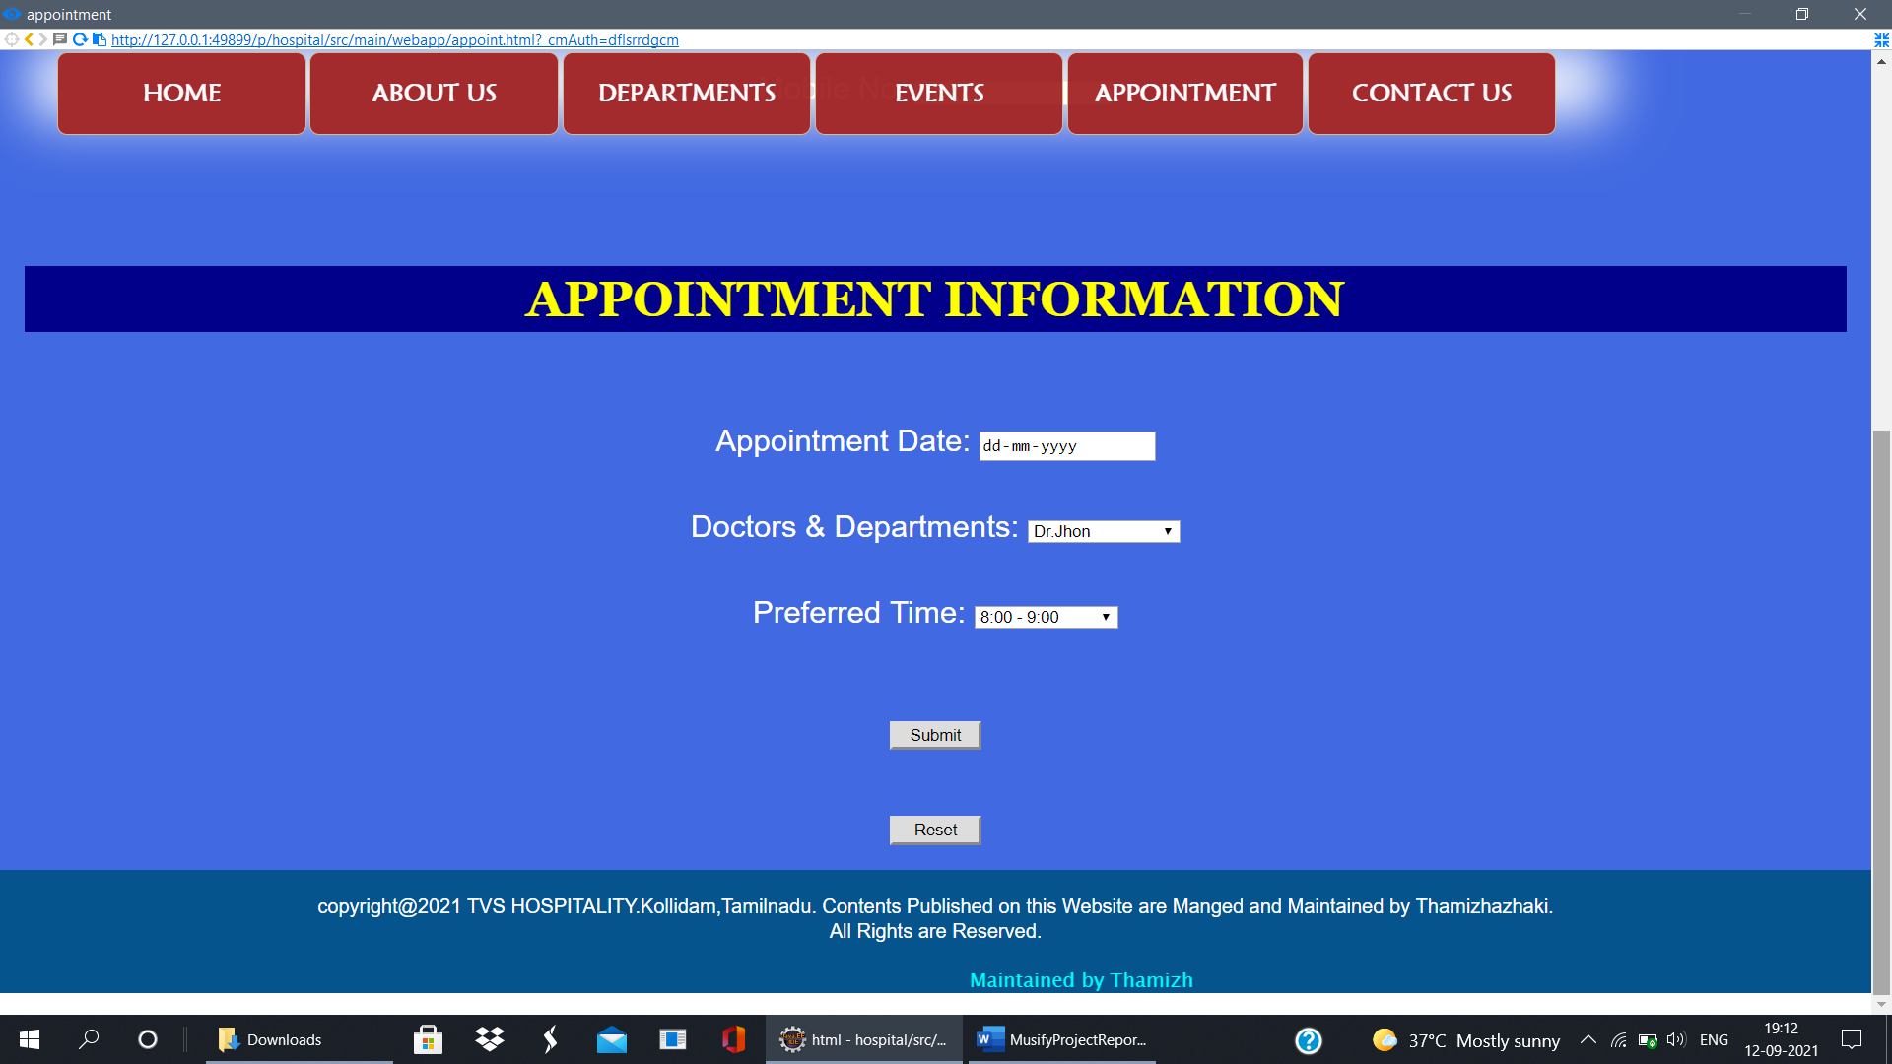

After appointment done

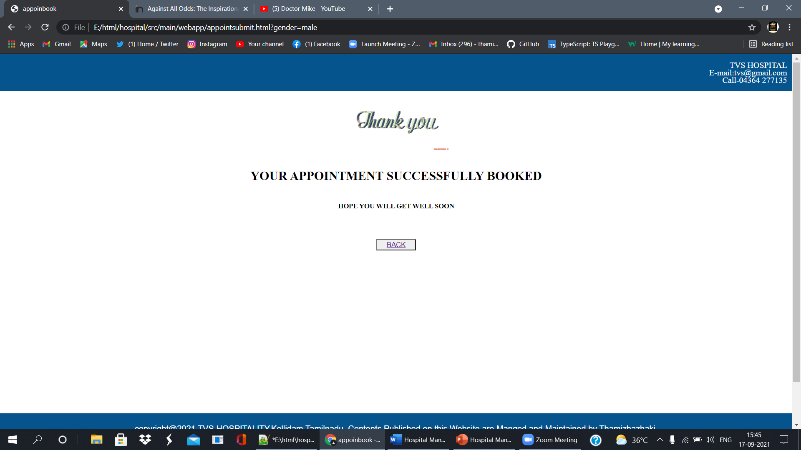

## CONTACT US

This module will help to know about the hospital location easily, and request the information about hospital and patient.

HTML file

<html>

<head>

<title>Contact US</title>

<link href="contactstyle.css" rel="stylesheet" type="text/css">

</head>

<body>

<div class="dett">

<center><a href="home.html" class="home">HOME</a></center>

TVS HOSPITAL<br>

E-mail:tvs@gmail.com<br>

Call-04364 277135

</div>

<h1><font size="6">REQUEST INFORMATION</font></h1><br><br>

<div class="box"></div>

<div class="appointmentform">

<form method="GET" action="contactsubmit.html">

<table>

<tr><td>Your Name</td><td>:

<input type="text" placeholder="Full Name" class="formname" required>

</td></tr><br>

<tr><td>E-mail</td><td>:

<input type="email" placeholder="EMail ID" class="formname" required>

</td></tr><br>

<tr><td>Your Message &nbsp; &nbsp;:</td><br><td> &nbsp; <textarea placeholder="Type Your Message Here" class="formname" style="height: 100px"></textarea>

</td></tr><br>

</table><br>

<a href="file:///E:/html/hospital/src/main/webapp/home.html">

<input type="submit" class="submitbn" >

</a>

<input type="reset" class="resetbtn">

</form>

</div>

<div class="address">

<font size="+2" face="Arial Black"><u>TVS BASE HOSPITAL</u></font><br><br>

<b>Address:</b>3/108,Perumal Kovil Street,Kollidam,Nagai dist,<br>&nbsp;&nbsp;&nbsp;&nbsp;&nbsp;&nbsp;&nbsp;&nbsp;&nbsp;&nbsp;&nbsp;&nbsp;TamilNadu,PinCode 609102<br><br>

<b>Phone:</b>8270444366<br><br>

</div><br>

<div class="mapouter">

<div class="gmap_canvas">

<iframe class="gmap_iframe" frameborder="0" scrolling="no" marginheight="0"marginwidth="0"src="https://maps.google.com/maps?width=600&amp;height=400&amp;hl=en&amp;q=kollidam&amp;t=&amp;z=14&amp;ie=UTF8&amp;iwloc=B&amp;output=embed"></iframe>

<a href="https://www.fridaynightfunkin.net/">Friday Night Funkin Download</a></div></div>

<a href="welcome.html">

<center><button class="button" type="button">back</button></center>

</a>

<divclass="copyright"><br>copyright@2021TVS HOSPITALITY.Kollidam,Tamilnadu.

Contents Published on this Website are Manged and Maintained by Thamizhazhaki.<br>

All Rights are Reserved.<br><br>

</div>

<div class="maintained">

<marquee> OWNED by Thamizh</marquee></div><br>

</body>

</html>

CSS Contact Style

*{

padding: 0;

margin: 0;

}

**body**

{

background-color: azure;

}

*.home*

{

color: blue;

font-size: 70px;

text-decoration:*dashed*;

margin-right: 100px;

line-height: 25px;

font-size: 30px;

}

*.home*:hover

{

border:*solid* blue6px;

}

*.dett*

{

text-align:*right*;

padding:0px80px0px80px;

background: blanchedalmond;

color: blueviolet;

font-family: *"Lucida Grande"*;

line-height: 15px;

}

*.formname*

{

width: 200px;

height: 30px;

border-radius: 5px;

}

*.appointmentform*

{

margin-top: 160px;

margin-left: 650px;

line-height: 40px;

color:white;

font-family: serif;

font-size : 20px;

}

*.address*

{

margin-top: -250px;

margin-left: 20px;

line-height: 20px;

color:brown;

font-family: serif;

font-size : 18px;

}

*.box*

{

box-sizing: *border-box*;

background: rgba*(*red*,* green*,* blue*, alpha)*;

width: 700px;

height: 600px;

margin-left: 330px;

margin-bottom: -930px;

border-radius: 30px;

display: *block*;

}

*.submitbn*

{

margin-left: 180px;

display: *inline-block*;

padding: 15px25px;

font-size: 20px;

cursor: *pointer*;

text-align: *justify*;

outline: *none*;

color: black;

background-color: *#fff*;

border: *none*;

border-radius: 15px;

box-shadow: 05px *#999*;

}

*.submitbn*:hover

{

background-color: *#0012a6*;

color:white;

}

*.submitbn*:active

{

background-color: *#0012a6*;

box-shadow: 05px *#666*;

transform: translateY*(*4px*)*;

}

*.resetbtn*

{

margin-left: 50px;

display: *inline-block*;

padding: 15px25px;

font-size: 20px;

cursor: *pointer*;

text-align: *justify*;

outline: *none*;

color: black;

background-color: *#fff*;

border: *none*;

border-radius: 15px;

box-shadow: 05px*#999*;

}

*.resetbtn*:hover

{

background-color: *#0012a6*;

color: white;

}

*.resetbtn*:active

{

background-color: *#0012a6*;

box-shadow: 05px*#999*;

transform: translateY*(*4px*)*;

}

**h1**

{

margin: 0px;

color: darkblue;

text-align: *center*;

background-color: white;

font-size: 40px;

}

*.copyright*

{

text-align:*center*;

padding:0px80px0px80px;

background: *#05548e*;

color: white;

font-family: *"Arial"*;

line-height: 20px;

}

*.maintained*

{

text-align:*right*;

padding:0px80px0px80px;

background: *#05548e*;

color: aqua;

font-family:*'Lucida Sans Unicode', 'Lucida Grande', 'Lucida Sans', 'Arial', 'sans-serif'*;

line-height: 20px;

}

*.mapouter*

{

position:*relative*;

text-align:*right*;

width:600px;

height:400px;

}

*.gmap_canvas*

{

overflow:*hidden*;

background:*none*!important;

width:600px;

height:400px;

}

*.gmap_iframe*

{

width:600px!important;

height:400px!important;

}

*.button*

{

border-radius: 2%;

height: 3%;

width: 5%;

}

Screenshots of Contact Us

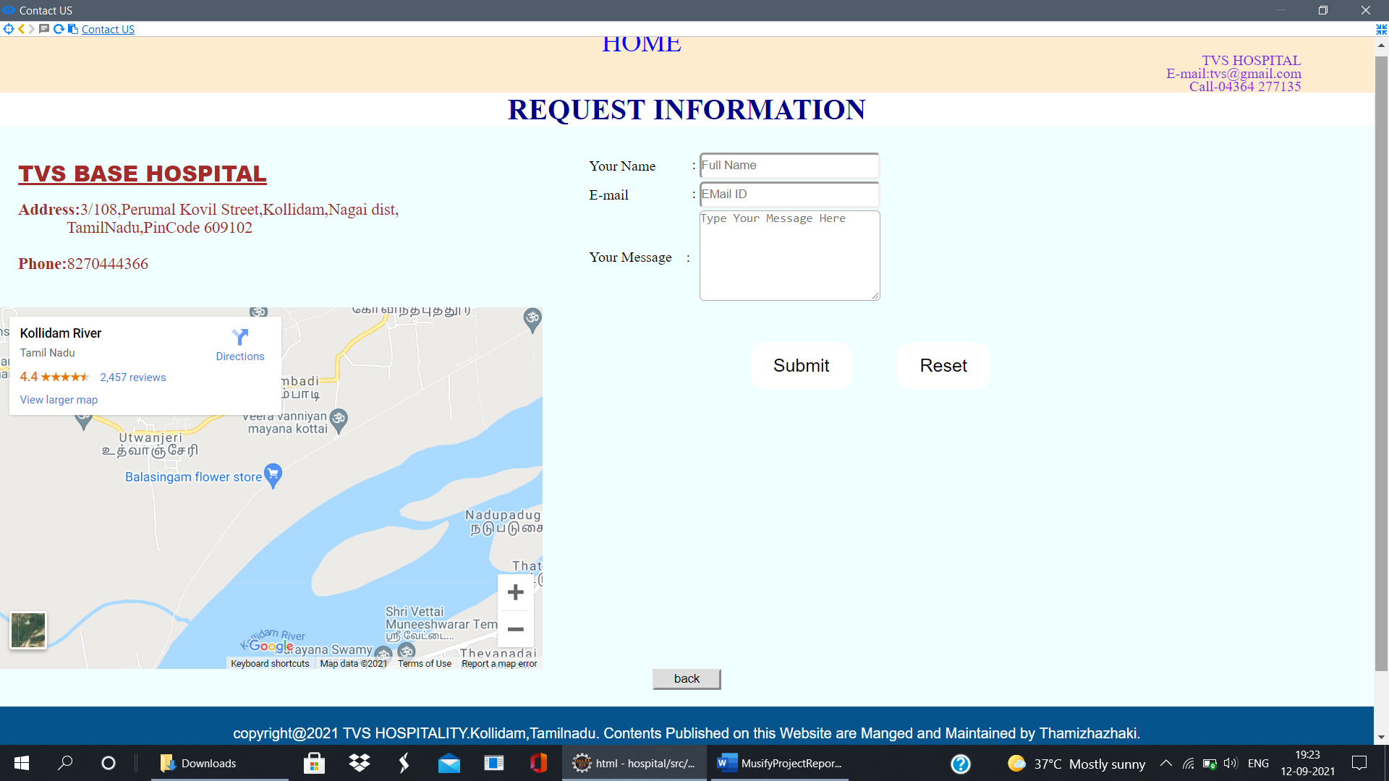

1.5.3.1

**Contact Feedback**

Html

<html>

<head>

<title>contact feedback</title>

<link href="contactstyle.css" rel="stylesheet" type="text/css">

</head>

<body>

<div class="dett">

<center><a href="home.html" class="home">HOME</a></center>

TVS HOSPITAL<br>

E-mail:tvs@gmail.com<br>

Call-04364 277135

</div>

<h1><font size="6">FEEDBACK FORM</font></h1><br><br>

<br><br>

<br><br>

<h2>Leave your Suggestion for any Improvement</h2><br>

<input type ="checkbox">Good Service<br>

<input type ="checkbox">Service to be Improved<br>

<input type ="checkbox">Need Change in care<br>

<input type ="checkbox">Hospital Facilites to be Improved <br><br>

<button onclick="myFunction()">Finish</button>

<br><br> <br><br> <br><br> <br><br> <br><br> <br><br> <br><br> <br>

<a href="welcome.html">

<center><button class="button" type="button">back</button></center><br>

</a>

<script>

function myFunction() {

alert("Thank You for Your Valuable Feedback");

}

</script>

<div class="copyright"><br>copyright@2021 TVS HOSPITALITY.Kollidam,Tamilnadu.

Contents Published on this Website are Manged and Maintained by Thamizhazhaki.<br>

All Rights are Reserved.<br><br>

</div>

<div class="maintained">

<marquee> OWNED by Thamizh</marquee></div><br>

</body>

</html>

Screenshots of Feedbackform

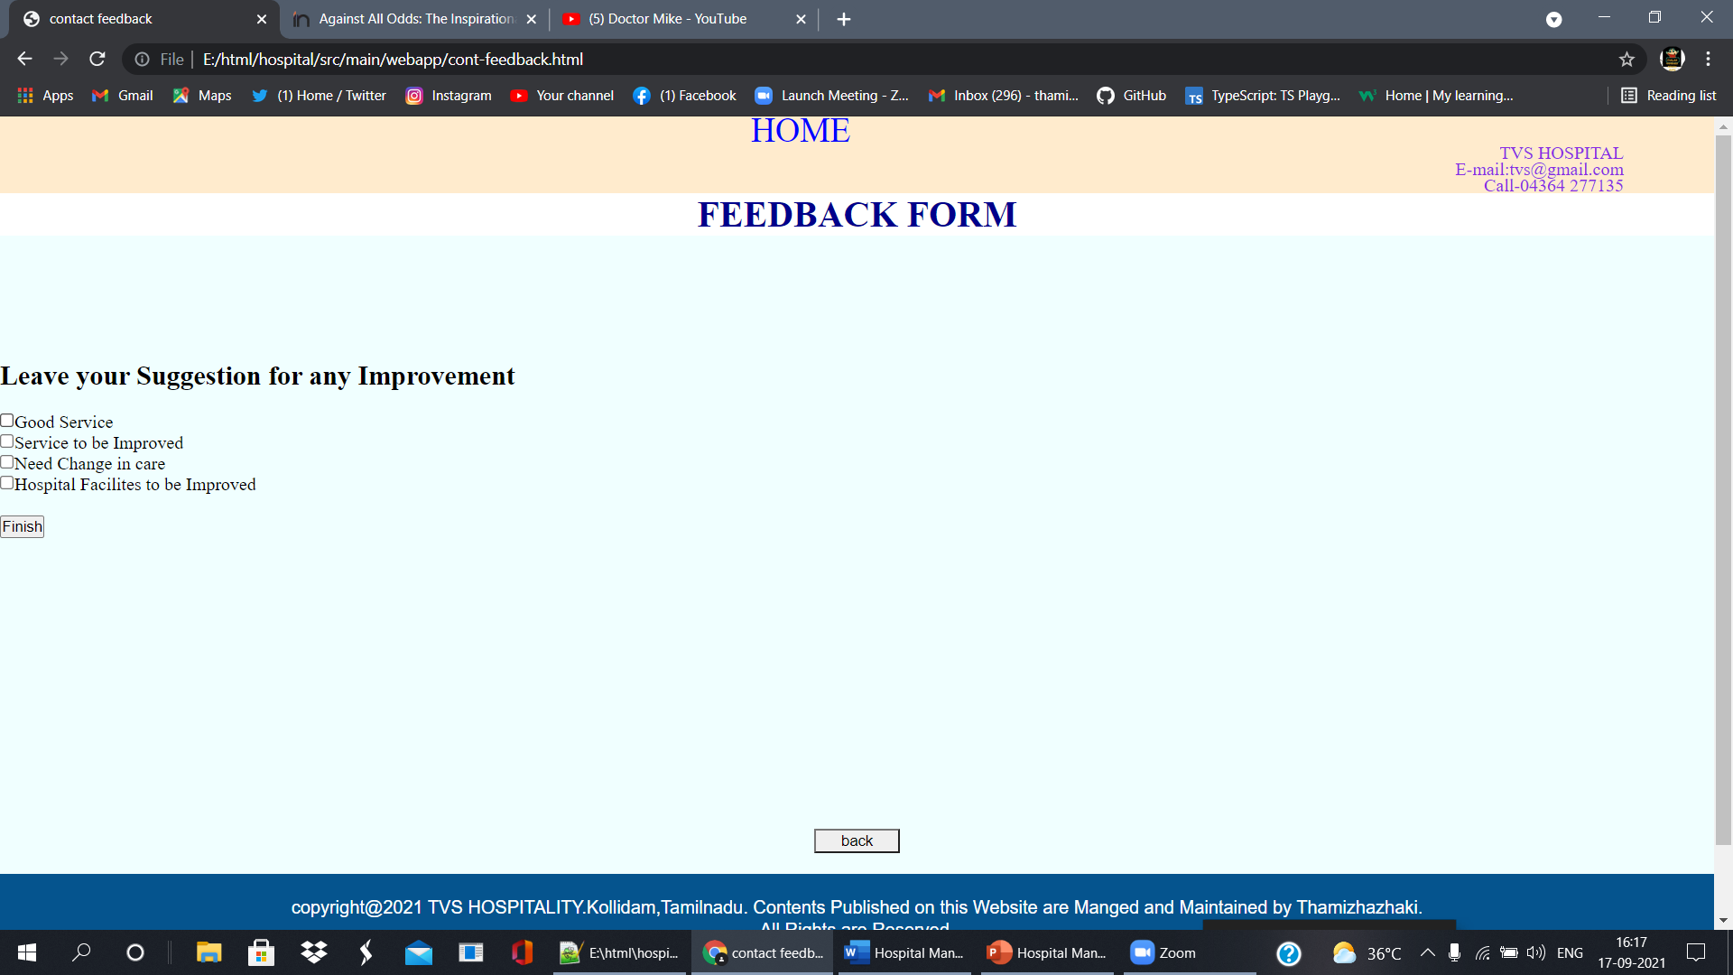

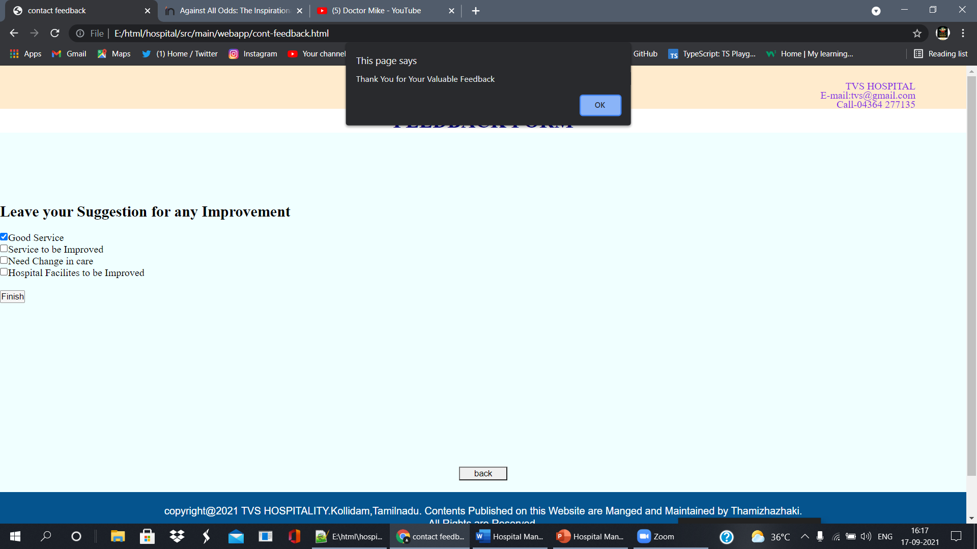

# ADVANTAGES

1. Easy appointment making.
2. Check doctors profile.
3. Easy location .
4. User-friendly.

**Chapter 2**

# CONCLUSIONS

**2.1 CONCLUSION**

HOSPITAL MANAGEMENT SYSTEM can be used by any people to search and appoint a doctor easily. Making appointment of multiple people for a big hospital is difficult by using a manual system and may be very time consuming .All these problems are solved by this project.